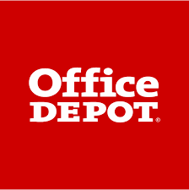
SMALL BUSINESS SAVINGS PROGRAM
Presented by: Administered by:

Website Paragraph
Add this paragraph to your chamber’s website where necessary. If possible, include the Office Depot logo and link to [Your chamber’s Office Depot portal link].

We’re proud to be a part of Office Depot’s Small Business Savings Program, presented by ChamberSolutions and administered by Excelerate America. Tailored to meet the modern needs of small and mid-sized enterprises, it supports the growth and development of local business communities through fantastic savings both in-store and online, plus preferred customer assistance, access to simplified tech services, and so more.

